ADSi Youth Project School Holiday Program
Young people 15 - 25 years old
1st – 12th of October 2018
Mon | Tue | Wed | Thu | Fri
1st  OFFICE CLOSED FOR PUBLIC HOLIDAY | 2nd  Macquarie University Tour  Meet @ ADSi  9:30am  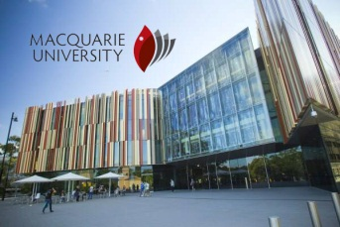  First 15  15 | 3rd  White Card Training  @XXX  9:30am  First 15  SURF LIFE SAVER  Meet @ ADSi  9am  First 20 | 4th  GAMES DAY  @ AYC  1 - 3pm | 5th  Soccer Tournement  @AYC  12pm – 4pm
8th  Healthy eating and Gardening  @ADSi  1:30pm | 9th  CITY Tour  Meet @ADSi  9:30am | 10th  Individual casework by appointment  @ ADSi  9am-4:30pm | 11th  Movie  @ ADSI  2pm | 12th  Volley Ball Competition  @ AYC  11am-4pm
To register Call: 0422 366 253 or 0401 876 346- Youth Team Ph : 8737 5500 or via email : molly@adsi.org.au or tamana@adsi.org.au

